Rohan Samanta
150096724134
MZ

Retail Outlet Location Clustering Using Machine Learning

1. Introduction
Retail companies need to select suitable locations when expanding their business. Different locations have different characteristics such as population density, household income, number of competitors, customer footfall, rental cost, and transportation accessibility.
The objective of this project is to group similar retail locations into meaningful categories using Machine Learning clustering techniques. Since there are no predefined categories for the locations, this project uses unsupervised learning.
The project applies K-Means Clustering and Agglomerative Hierarchical Clustering. The optimal number of clusters is determined using the Elbow Method, WCSS, Silhouette Score, Davies-Bouldin Index, and a dendrogram. PCA is also used to reduce the six-dimensional data to two dimensions for visualization.
The final K-Means model is deployed through a Streamlit web application where a user can enter the characteristics of a new location and receive its corresponding location category.

2. Problem Statement
A retail company planning expansion wants to group candidate locations based on:
- Population density
- Average household income
- Competitor count
- Footfall estimate
- Rental cost
- Transport accessibility
The company wants to identify location types with similar characteristics. These groups can support expansion planning by helping decision-makers understand different types of retail environments.
The dataset does not have predefined labels, so clustering is used to discover the natural groups in the data.

3. Objectives
The main objectives of the project are:
- Generate a realistic synthetic retail-location dataset.
- Perform exploratory data analysis and visualization.
- Identify and handle missing values.
- Scale the features before clustering.
- Apply K-Means clustering.
- Apply Agglomerative Hierarchical Clustering.
- Determine the optimal number of clusters.
- Compare the results of the two clustering techniques.
- Use PCA for dimensionality reduction and visualization.
- Profile and interpret each cluster.
- Test cluster stability.
- Deploy the trained K-Means model using Streamlit.
- Analyze the limitations and real-world applicability of the model.

4. Dataset Generation
A standard public dataset containing all the required retail-location attributes was not available. Therefore, a synthetic dataset was generated using Python and NumPy.
The dataset contains 800 retail locations.
Each location contains six main numerical features:
Feature | Description
Population Density | Number of people in the surrounding area
Average Household Income | Approximate purchasing power of households
Competitor Count | Number of competing businesses
Footfall | Estimated number of people passing through the location
Rental Cost | Approximate rental cost
Transport Accessibility | Accessibility through transportation facilities
The synthetic data was generated using five realistic location archetypes:
- Dense Premium City-Centre
- Affluent Quiet Suburbs
- Busy Budget Markets
- Low-Density Peripherals
- Transit-Hub Commercial Zones
Random variation was added to the generated values so that the dataset would resemble real-world data rather than containing identical values.
The true_archetype information was used only during data generation and analysis. It was not used as an input feature for clustering.

5. Exploratory Data Analysis
Exploratory Data Analysis (EDA) was performed to understand the characteristics and distribution of the dataset.
The analysis included:
- Checking the number of records and features.
- Examining descriptive statistics.
- Checking for missing values.
- Visualizing feature distributions.
- Examining relationships between features.
- Observing possible differences between location types.
EDA helps identify data-quality issues before applying machine learning algorithms.

6. Missing Value Handling
Missing values were deliberately introduced into the synthetic dataset to simulate incomplete real-world data.
Missing values were introduced mainly in:
- Footfall
- Rental Cost
Instead of simply replacing missing values with a global mean, the project uses KNN Imputation.
The implementation uses:
KNN Imputer with 5 neighbors.
KNN Imputation finds observations that are similar to the location containing the missing value and uses information from those neighboring observations to estimate the missing value.
This is useful because retail-location features can be related to each other.

7. Feature Scaling
Feature scaling is necessary because the variables have different numerical ranges.
For example:
- Income may be measured in tens or hundreds of thousands.
- Population may be measured in thousands.
- Competitor count may be around tens.
- Transport accessibility may be measured on a smaller scale.
K-Means and hierarchical clustering use distances between data points. Without scaling, features with larger numerical values could have an unnecessarily large influence on the distance calculation.
Therefore, StandardScaler was used.
StandardScaler transforms the features approximately so that:
- Mean = 0
- Standard deviation = 1
The formula is:
[
z = \frac{x-\mu}{\sigma}
]
where:
- (x) = original value
- (\mu) = mean
- (\sigma) = standard deviation

8. K-Means Clustering
K-Means is an unsupervised machine learning algorithm that divides data into a specified number of clusters.
The basic process is:
- Select the number of clusters (K).
- Initialize (K) centroids.
- Assign every data point to its nearest centroid.
- Recalculate the centroid of each cluster.
- Repeat the assignment and recalculation steps until the clusters become stable.
A centroid represents the center or mean position of a cluster.
The project uses K-Means with:
- Number of clusters = 5
- K-Means++ initialization
- Scaled features
K-Means++ provides a more effective initialization of the starting centroids.

9. Within-Cluster Sum of Squares (WCSS)
WCSS stands for Within-Cluster Sum of Squares.
It measures the total squared distance between data points and the centroid of their assigned cluster.
A lower WCSS indicates that the data points are more compact around their cluster centers.
However, WCSS normally decreases as the number of clusters increases. Therefore, it cannot be used alone to select the optimal number of clusters.

10. Elbow Method
The Elbow Method was used to determine a suitable number of clusters.
WCSS was calculated for different values of K, from 2 to 10.
As K increases, WCSS decreases. However, after a certain point, adding more clusters produces only a small improvement.
This point is called the elbow.
The project identified K = 5 as the appropriate number of clusters because there was a major improvement up to five clusters and comparatively smaller improvements after that.

11. Silhouette Score
The Silhouette Score evaluates how well each data point fits within its assigned cluster compared with other clusters.
Its value generally ranges from -1 to +1.
- Close to +1: strong separation
- Around 0: overlapping clusters
- Negative: possible incorrect assignment
For the selected five-cluster solution, the project obtained a Silhouette Score of approximately:
0.7814
This indicates relatively good cluster separation and cohesion.
The Silhouette Score should not be interpreted as model accuracy.

12. Davies-Bouldin Index
The Davies-Bouldin Index is another clustering evaluation metric.
It considers the similarity between clusters based on their internal spread and separation.
For this metric:
Lower values are generally better.
For the selected five-cluster solution, the project obtained a value of approximately:
0.3125
This provides additional support for the selected clustering structure.

13. Hierarchical Clustering
The project also applies Agglomerative Hierarchical Clustering.
Agglomerative clustering begins with every data point as an individual cluster.
It then repeatedly merges the closest clusters until the required number of clusters is obtained.
The project uses Ward linkage.
Ward linkage attempts to merge clusters while minimizing the increase in within-cluster variance.
Unlike K-Means, hierarchical clustering produces a hierarchy of merged groups.

14. Dendrogram
A dendrogram is a tree-like visualization used to represent hierarchical clustering.
It shows:
- Which clusters are merged.
- The order of merging.
- The distance at which clusters are merged.
By drawing a horizontal line across the dendrogram, the number of resulting groups can be observed.
The dendrogram supported the use of approximately five clusters.

15. Comparison of K-Means and Hierarchical Clustering
Both clustering techniques were applied to the same scaled dataset.

K-Means
- Centroid-based.
- Requires K to be selected.
- Efficient for larger datasets.
- Provides cluster centroids.
- Can assign new observations to existing clusters.

Hierarchical Clustering
- Builds a hierarchy of clusters.
- Can be visualized using a dendrogram.
- Does not require the same centroid-based process.
- Standard AgglomerativeClustering does not provide a normal predict() method for unseen observations.
The two clustering approaches produced highly consistent results. The project obtained an Adjusted Rand Index (ARI) of 1.0, indicating complete agreement between the resulting partitions for this synthetic dataset.

16. Optimal Number of Clusters
The project selected:

K = 5
The decision was based on multiple sources of evidence:
- Elbow Method
- WCSS
- Silhouette Score
- Davies-Bouldin Index
- Hierarchical clustering dendrogram
Using multiple evaluation methods is more reliable than relying on a single metric.

17. PCA — Principal Component Analysis
PCA stands for Principal Component Analysis.
The original dataset contains six features, which makes direct visualization difficult.
PCA transforms the original features into a smaller number of new variables called principal components.
The project reduces:
6 dimensions → 2 dimensions
The first two principal components explain approximately 90.4% of the variance in the data.
PCA was mainly used to visualize the clusters in a two-dimensional graph.
PCA does not create the clusters. The clustering algorithms operate on the scaled feature data, while PCA is used mainly for dimensionality reduction and visualization.

18. Cluster Profiles
The five discovered clusters were interpreted based on their feature characteristics.

Cluster 0 — Busy Budget Markets
Characteristics:
- High population
- Lower average income
- High competitor count
- High footfall
- Moderate rental cost
- Good transport accessibility
This represents busy markets where many people are present but competition is also relatively high.

Cluster 1 — Affluent Quiet Suburbs
Characteristics:
- Lower population density
- High household income
- Few competitors
- Lower footfall
- Moderate rental cost
- Moderate transport accessibility
This represents wealthy but relatively quiet suburban locations.

Cluster 2 — Dense Premium City-Centre
Characteristics:
- High population density
- High household income
- High competition
- High footfall
- Highest rental cost
- High transport accessibility
This represents premium central commercial areas with strong activity but high operating costs.

Cluster 3 — Low-Density Peripherals
Characteristics:
- Low population
- Lower income
- Few competitors
- Low footfall
- Lowest rental cost
- Lower transport accessibility
These are peripheral or less-developed areas with lower operating costs but lower customer activity.

Cluster 4 — Transit-Hub Commercial Zones
Characteristics:
- Moderate population
- Relatively strong income
- High competition
- Highest footfall
- High rental cost
- Highest transport accessibility
These areas are strongly connected to transportation networks and experience high pedestrian activity.

19. Why Clustering Cannot Determine the Best Location
Clustering identifies groups of similar locations. It does not determine which group is commercially the best.
For example, a location may have extremely high footfall but also very high rent and competition.
Another location may have lower footfall but much lower rent.
The commercially attractive option depends on factors such as:
- Business model
- Expected revenue
- Operating cost
- Target customers
- Profit margin
- Budget
- Competition
- Return on investment
Therefore, clustering should be treated as a decision-support tool, not a direct business ranking system.

20. Cluster Stability
Cluster stability was evaluated by repeating the clustering process using different random seeds and by performing repeated subsampling experiments.
The results showed very high agreement between the resulting cluster assignments.
The repeated subsampling experiment produced an average ARI of approximately 0.9982.
This indicates that the discovered clustering structure is highly stable for the generated dataset.
However, real-world data may produce less stable results because it contains more noise, outliers and overlapping location types.

21. Deployment
The trained K-Means model was deployed using Streamlit.
The web application allows a user to enter:
- Population density
- Average household income
- Competitor count
- Footfall
- Rental cost
- Transport accessibility
The input then passes through the same preprocessing pipeline used during training.
The process is:
User Input → Missing Value Handling → Scaling → K-Means → Nearest Centroid → Location Category
The application displays:
- Assigned cluster
- Location category
- Cluster profile
- Location characteristics
- Expansion-related notes
- Prediction details
- Cluster comparison information

22. Why K-Means Was Used for Deployment
K-Means provides explicit cluster centroids.
When a new location is entered, its features can be processed using the same imputer and scaler and then compared with the existing cluster centroids.
The new location is assigned to the closest centroid.
Standard Agglomerative Hierarchical Clustering does not provide a normal prediction method for assigning new unseen observations.
Therefore, K-Means is more suitable for real-time deployment.

23. Technologies Used
The project uses the following technologies:
- Python — Main programming language
- NumPy — Numerical operations and synthetic data generation
- Pandas — Data manipulation and analysis
- Scikit-learn — Machine learning algorithms and preprocessing
- Matplotlib / Seaborn — Data visualization
- Joblib — Saving and loading trained ML models
- Streamlit — Interactive web application
- PCA — Dimensionality reduction
- K-Means — Main clustering algorithm
- Agglomerative Clustering — Hierarchical clustering

24. Limitations
The project has several limitations.

1. Synthetic Dataset
The dataset is artificially generated and may not represent all real-world retail environments.

2. Limited Features
Only six location characteristics are considered. Real retail decisions may also depend on parking availability, road visibility, zoning laws, customer demographics, nearby landmarks, crime rates, existing sales data and other factors.

3. No Direct Profitability Prediction
The model does not predict sales, profit or return on investment.

4. K-Means Assumptions
K-Means works best when clusters are relatively compact and well separated. Real-world location patterns may be more complex.

5. Changing Conditions
Location characteristics can change over time. New transportation infrastructure, competitors, construction and changes in rent can affect a location.

6. Synthetic Clusters Are Well Separated
Because the synthetic data was intentionally generated around distinct archetypes, the clustering results are very clean. Real-world data would likely have more overlap and noise.

25. Real-World Applicability
The model can support retail expansion planning by helping companies:
- Segment candidate locations.
- Identify similar markets.
- Compare location characteristics.
- Understand different types of retail environments.
- Use cluster profiles as an initial screening tool.
However, the clustering output should be combined with business and financial analysis before making an actual expansion decision.

26. Conclusion
This project demonstrates how unsupervised machine learning can be used to segment retail locations based on their characteristics.
A synthetic dataset containing 800 locations and six attributes was created. Missing values were handled using KNN Imputation and the features were standardized using StandardScaler.
K-Means and Agglomerative Hierarchical Clustering were applied and compared. Multiple evaluation techniques supported a five-cluster solution. The clusters represented Busy Budget Markets, Affluent Quiet Suburbs, Dense Premium City-Centre locations, Low-Density Peripherals and Transit-Hub Commercial Zones.
PCA was used to visualize the six-dimensional dataset in two dimensions. The clustering results were also found to be highly stable on the synthetic data.
Finally, the K-Means model was deployed using Streamlit, allowing new candidate locations to be assigned to one of the discovered categories.
The most important conclusion is that clustering identifies groups of similar locations but does not determine which location is commercially the most attractive. It is therefore a decision-support tool rather than a complete retail location-selection system.

PROJECT SS

Cluster 1 — Affluent Quiet Suburbs
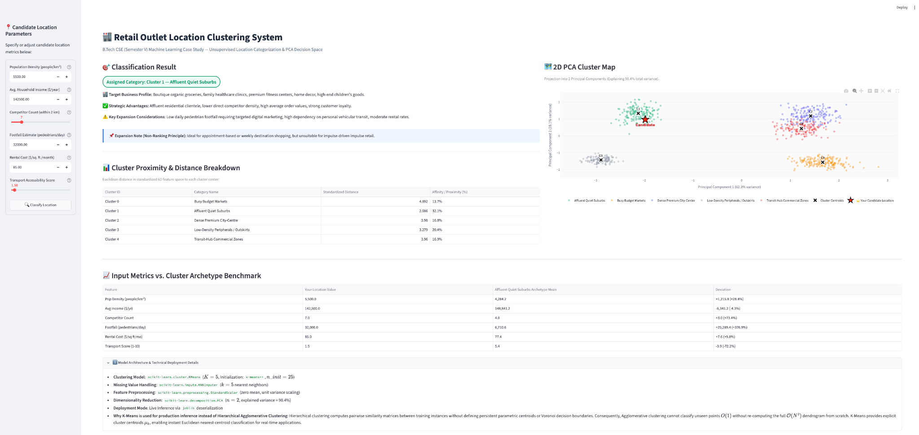

Cluster 2 — Dense Premium City-Centre
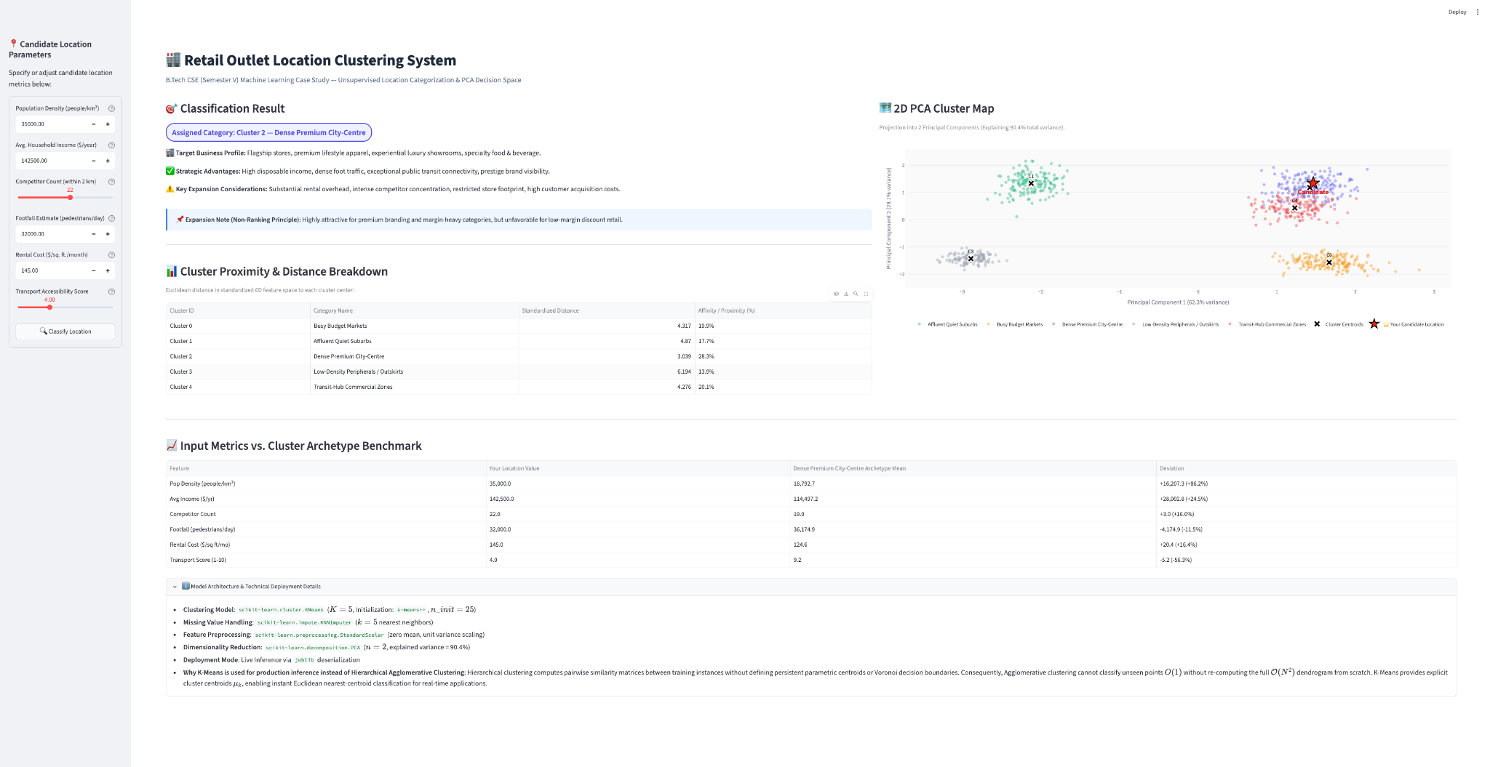

Cluster 4 — Transit-Hub Commercial Zones
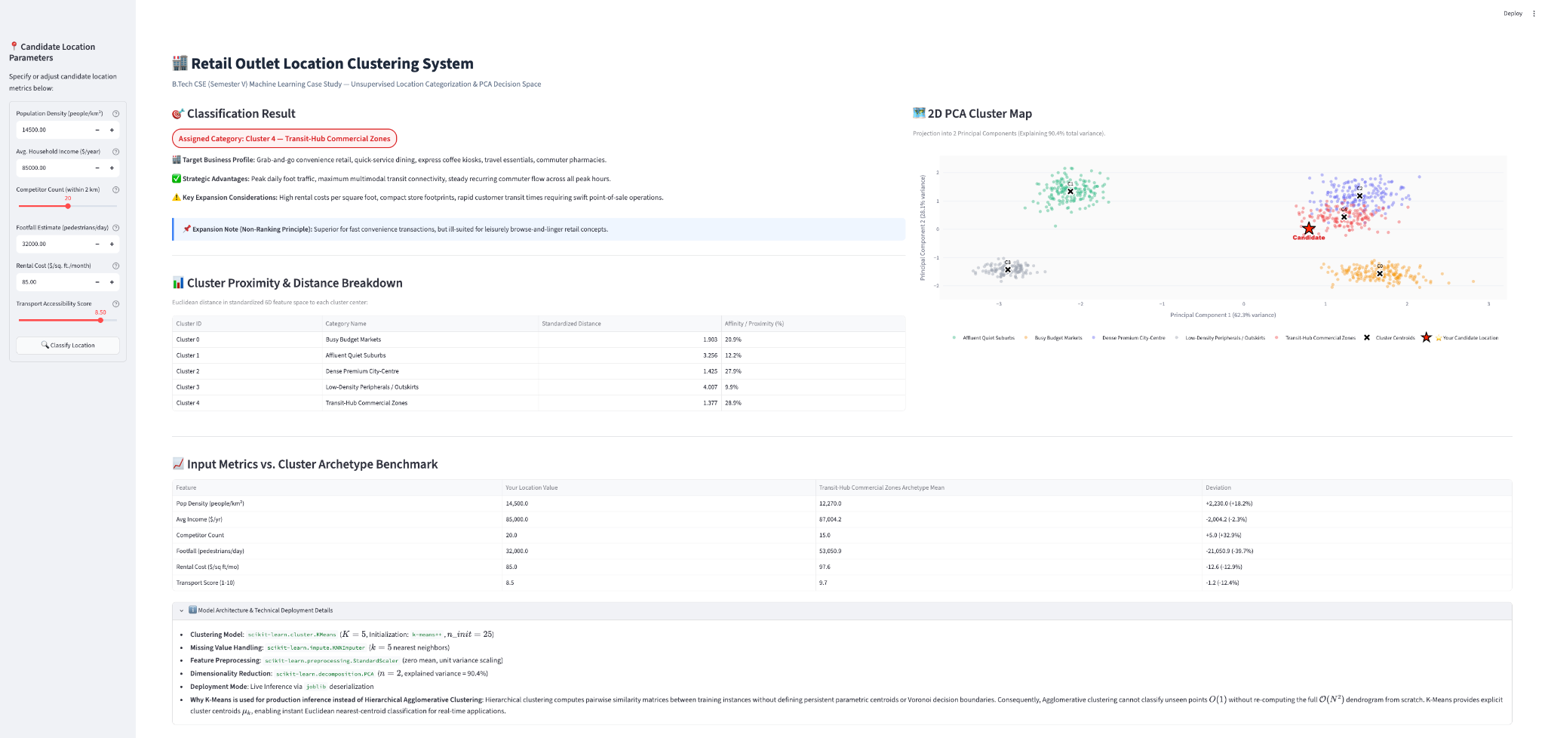

Cluster 3 — Low-Density Peripherals
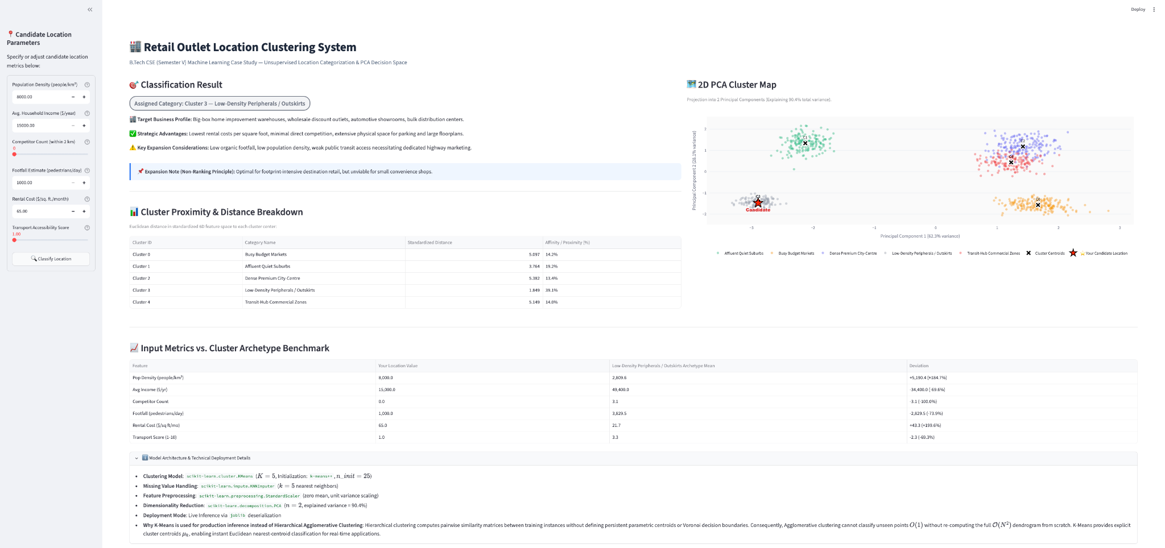

Cluster 0 — Busy Budget Markets
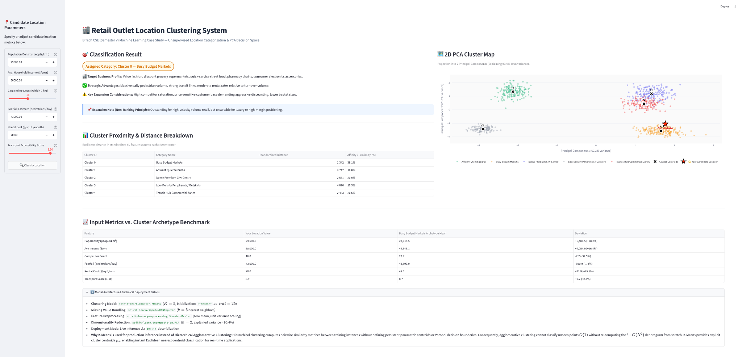

GRAPHS

1.Cluster profiling heatmap
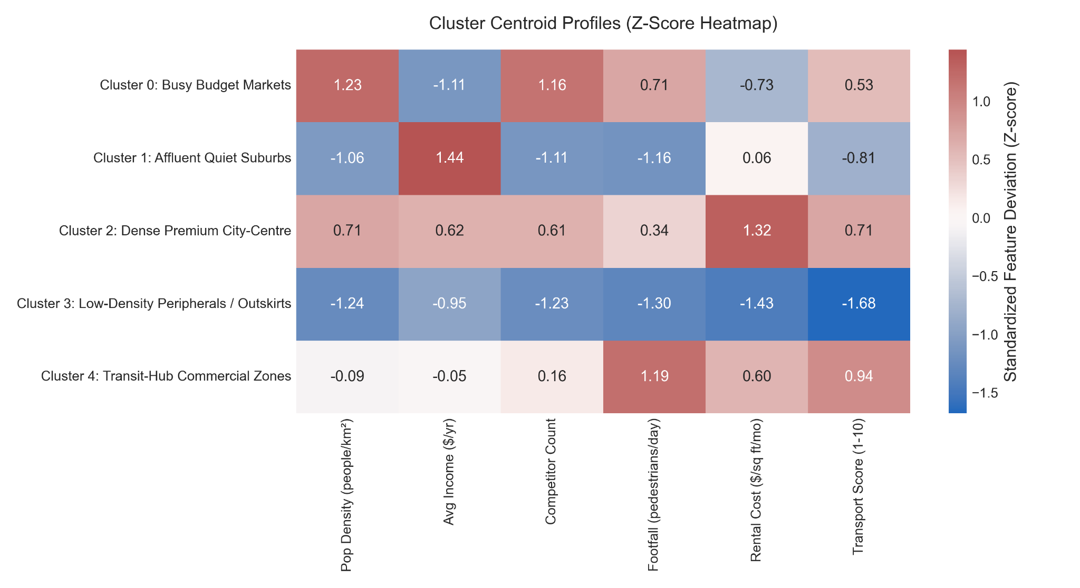
2.Cluster size distribution

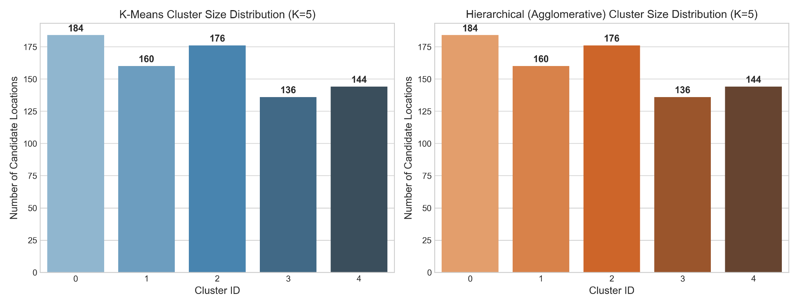

3.Correlation Heatmap
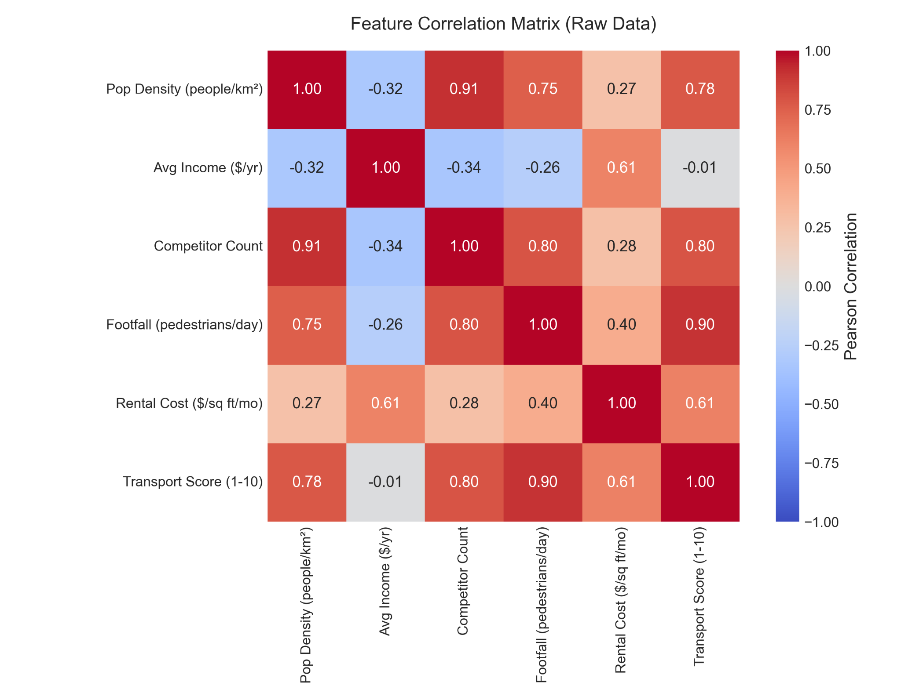

4.Dendrogram cut
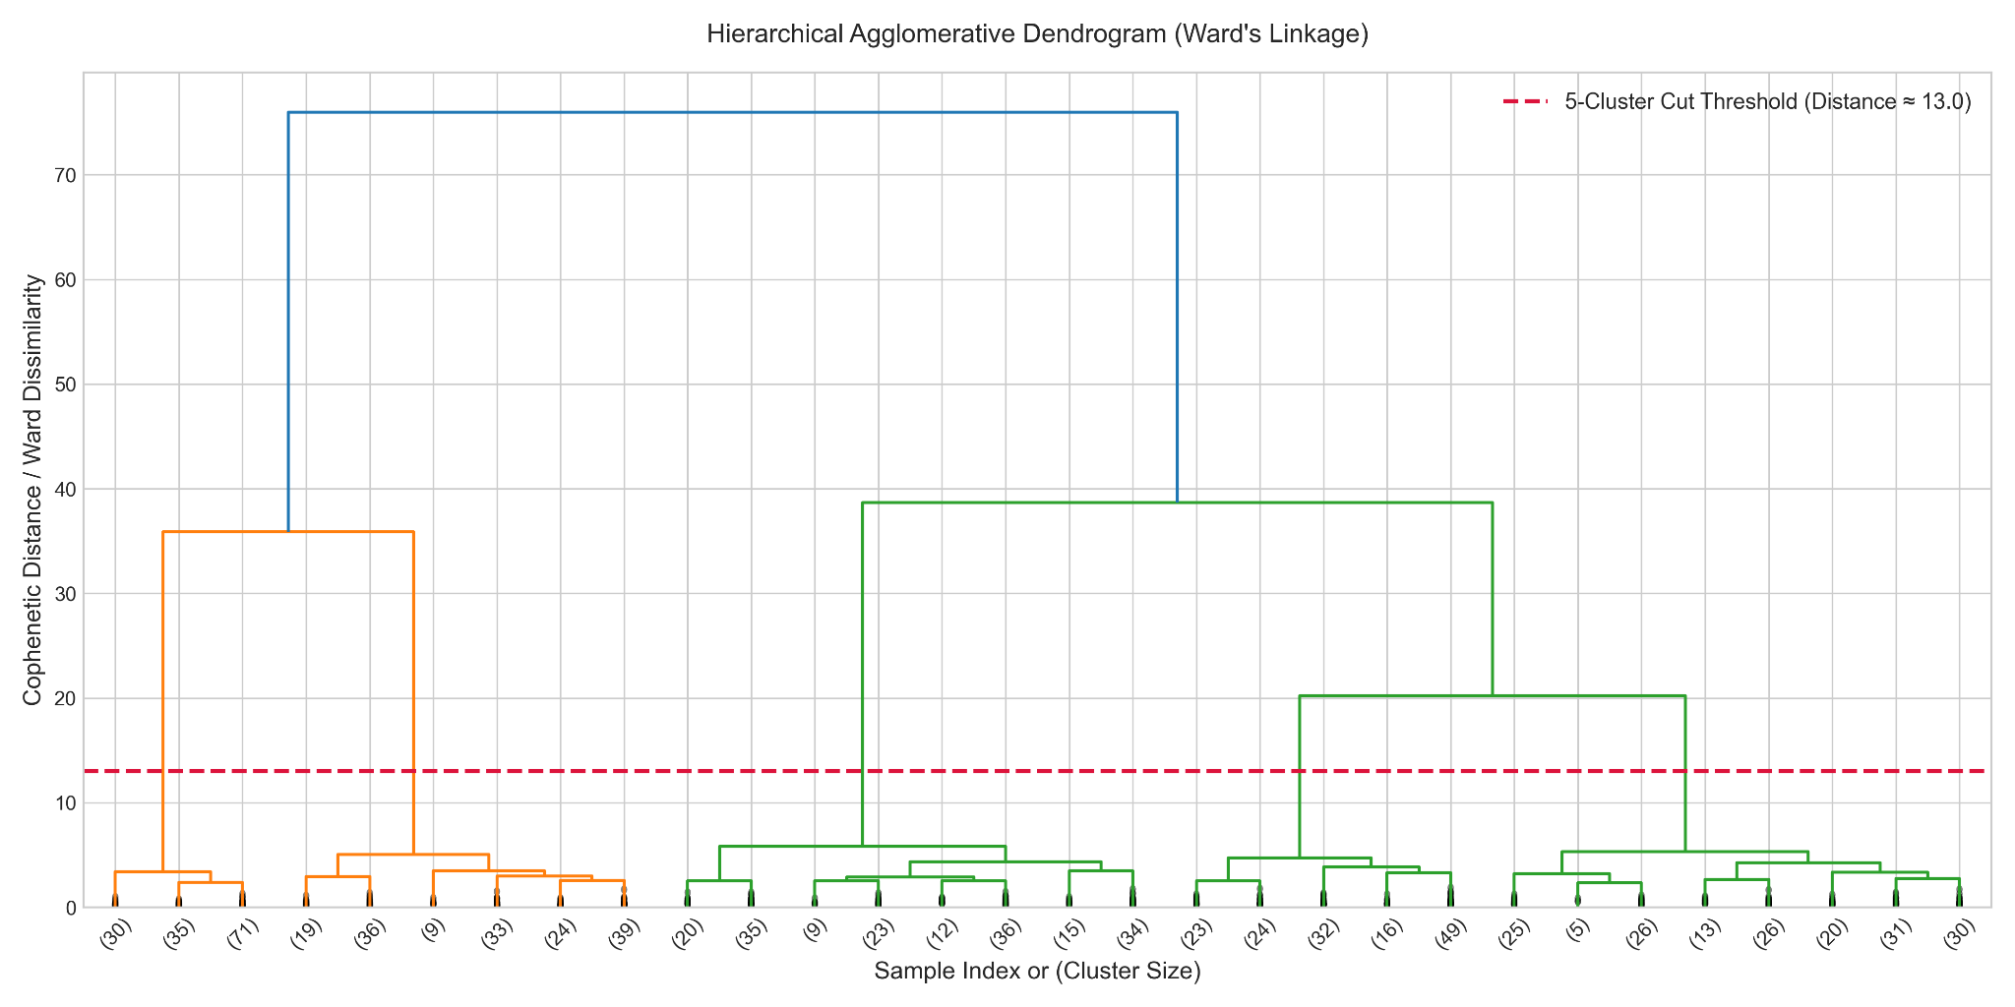
5.EDA Boxplots
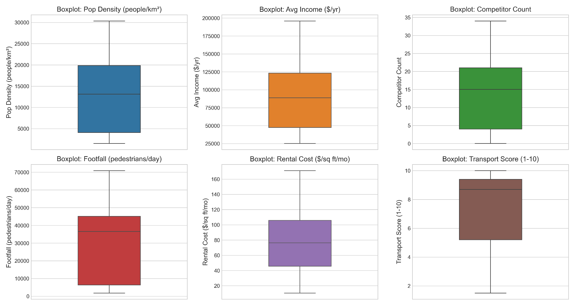

6.EDA distributions
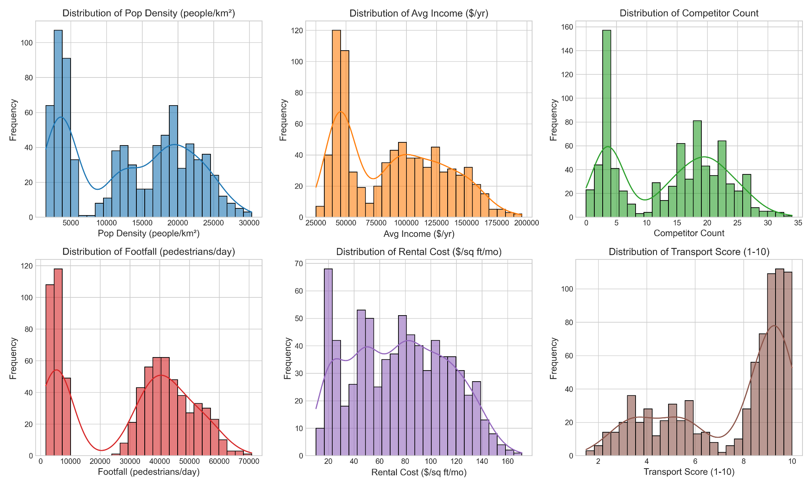
7.Elbow silhouette curve
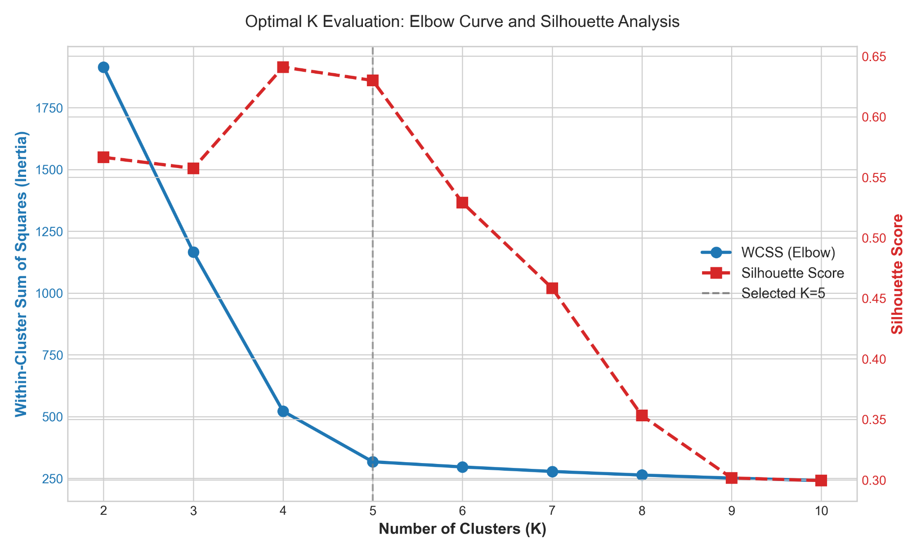

8.PCA cluster scatter
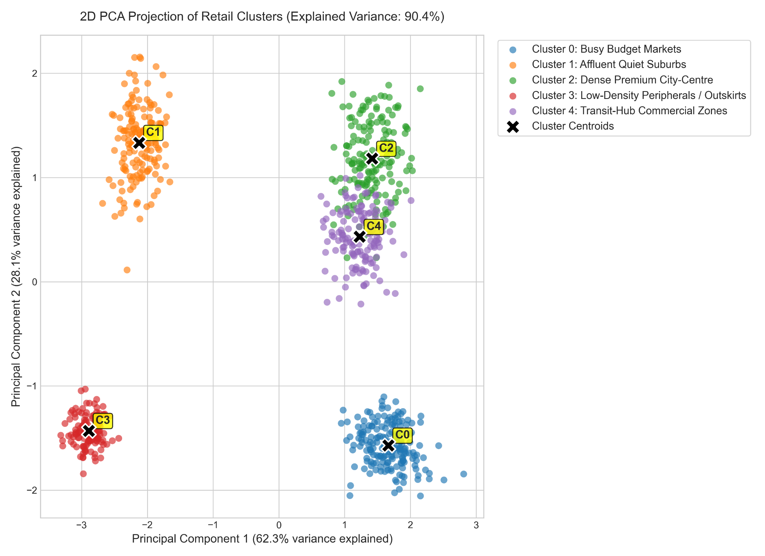
9.Stability ARI distribution
